**Name:** Raja Danyal Mushtaq **Email:** rajadanyal.fui@gmail.com

**Hand-on Exercise:** 02 **Batch:** 05 WordPress

1. Choose a Domain name and install WordPress on any hosting.

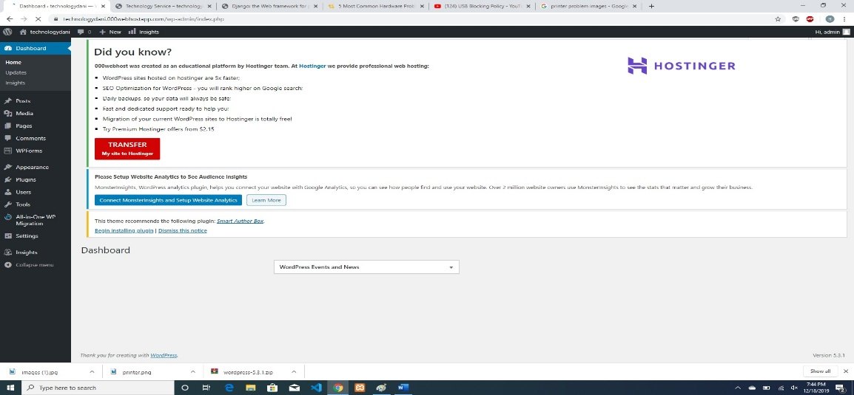

1. Install any theme of your choice.

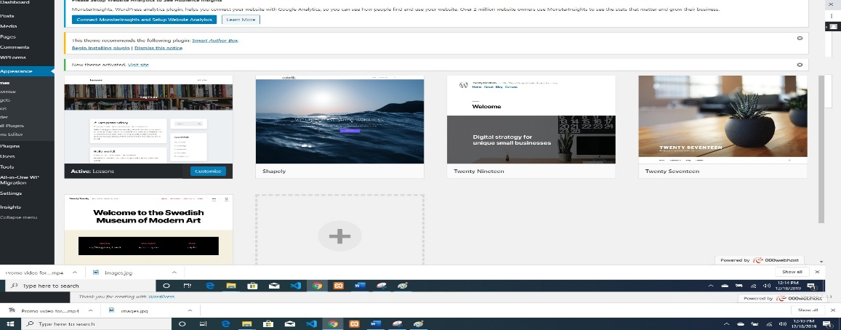

1. Add a logo to your website.

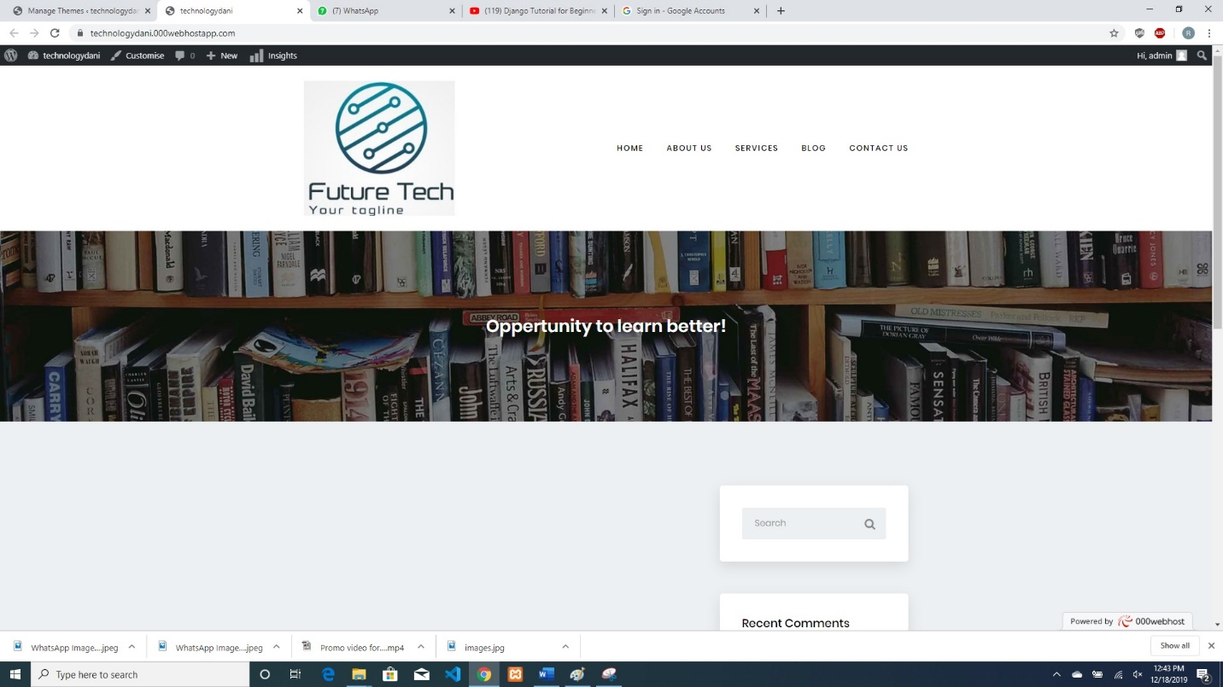

1. Add two posts (also add picture/video) and assign them to different categories.

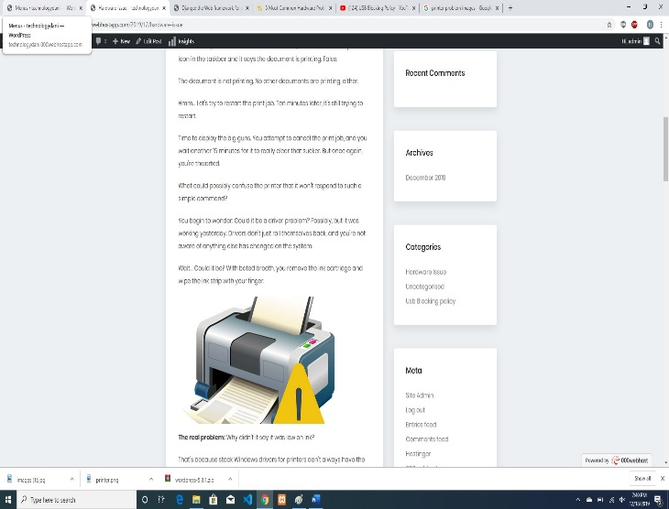

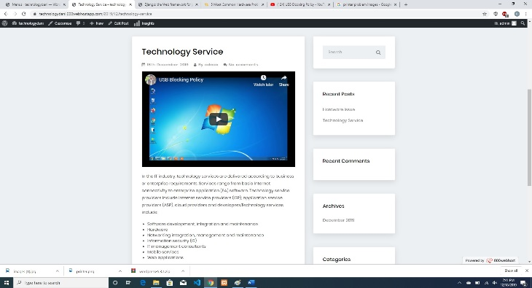

1. Create a menu using these categories.

